AWS Secrets Manager
Objective
To understand AWS Secrets Manager and securely store database credentials instead of hardcoding them in application code.

What is AWS Secrets Manager?
AWS Secrets Manager is a fully managed AWS service that securely stores, retrieves, and manages sensitive information such as:
- Database usernames
- Database passwords
- API Keys
- Access Tokens
- SSH Keys
- Third-party application credentials
Instead of writing passwords inside application code, applications retrieve them securely whenever needed.

Why do we need AWS Secrets Manager?
Without Secrets Manager:
Application
│
▼
Password stored inside code ❌
Problems:
- Password is visible in the source code.
- Developers may accidentally expose passwords.
- Password updates require code changes and redeployment.
- Less secure.

With Secrets Manager:
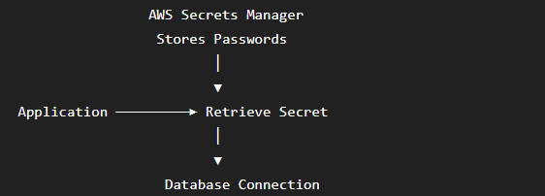
Benefits:
- Passwords are encrypted.
- Applications retrieve passwords securely.
- Easy password rotation.
- No hardcoded credentials.
- Centralized secret management.

Real-Time Use Case
An e-commerce application connects to a MySQL database.
Instead of storing the database password inside the application code:
password = "Password@123" ❌
The application retrieves it securely from AWS Secrets Manager.
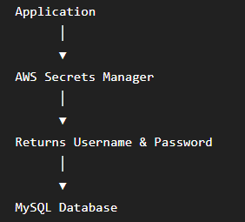

Architecture
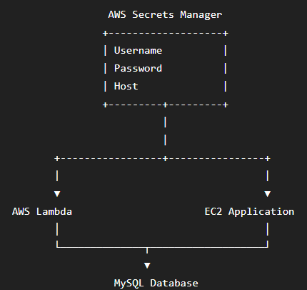

Services Used
- AWS Secrets Manager
- AWS IAM
- AWS Lambda (optional)
- Amazon EC2 (optional)

Step 1: Create a Secret
AWS Console
↓
Secrets Manager
↓
Store a new secret

Choose
Credentials for Amazon RDS database
(or other type of secret if you're not using RDS.)
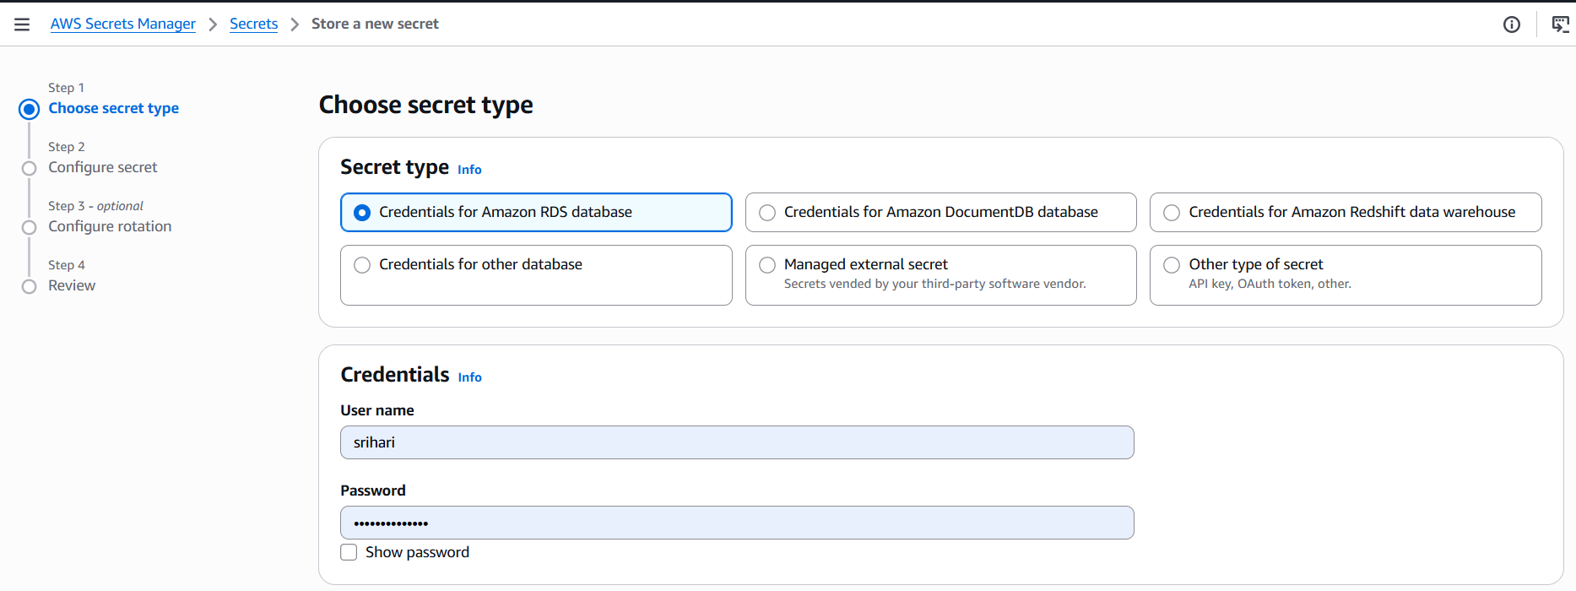

Enter
Username
admin
Password
Password@123

Secret Name
DatabaseCredentials
Click Next → Store.
Screenshot: Secret Created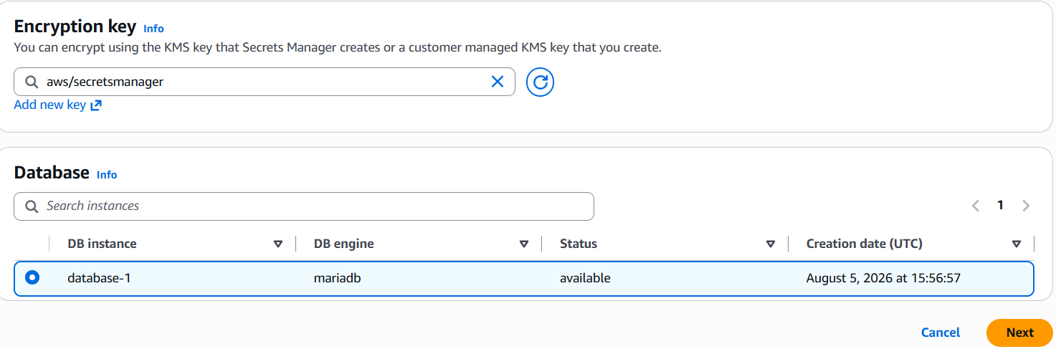
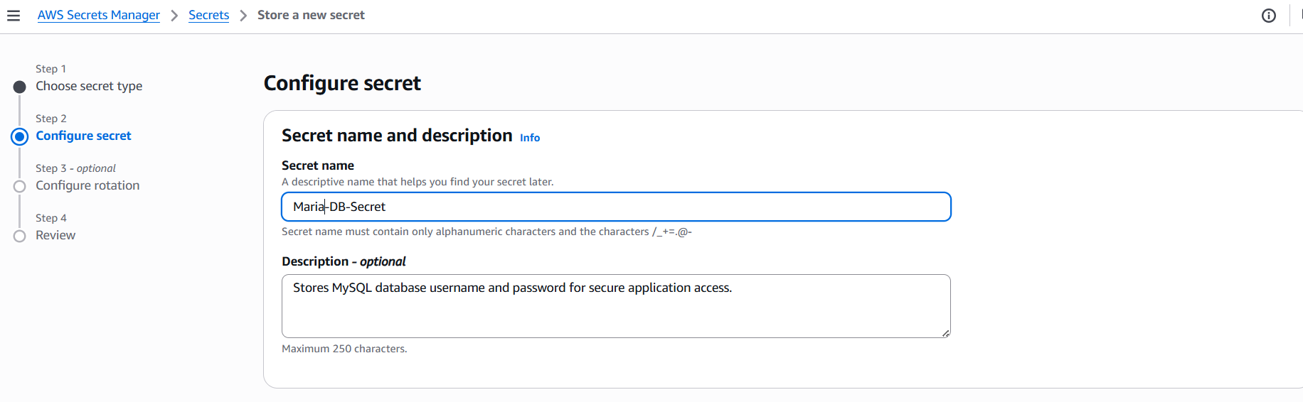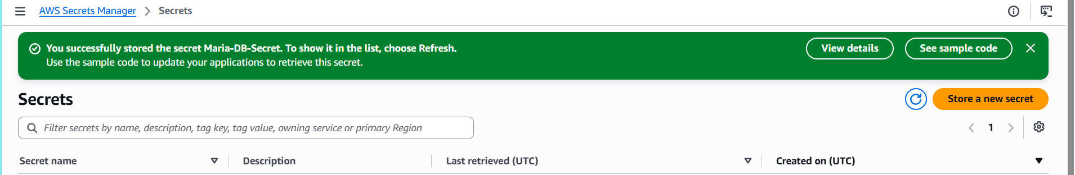

Step 2: Open the Secret
Open
DatabaseCredentials
You should see
Username
admin
Password will be hidden.
Screenshot: Secret Details
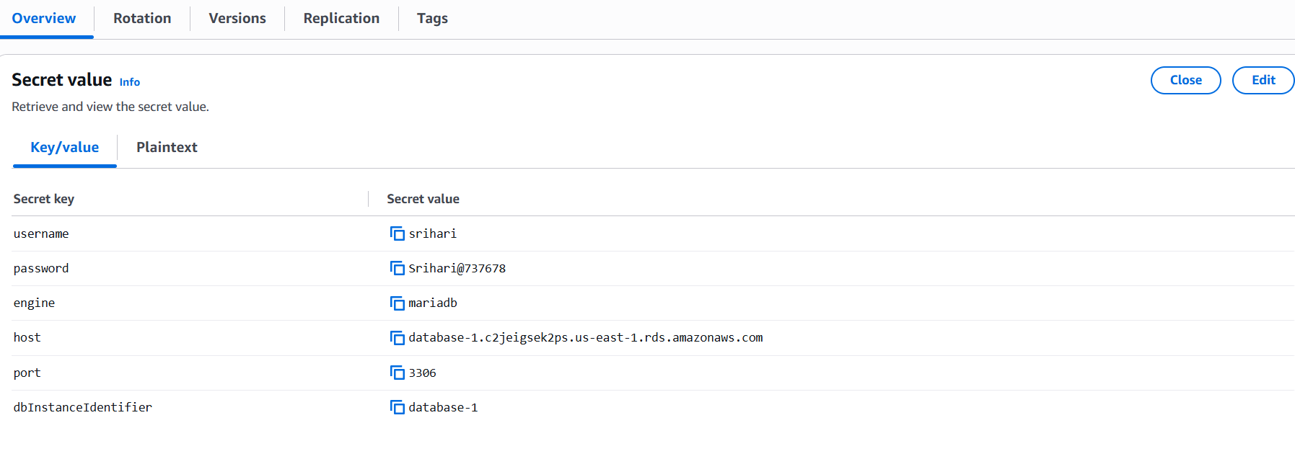

Retrieve Secret from Lambda
Step 1: Find the Lambda Execution Role
- Open AWS Lambda
- Click your function (OrderProcessor)
- Go to Configuration
- Click Permissions
You will see something like:
Execution role
OrderProcessor-role-abc123
Click the role name.
It opens the IAM Console.

Step 2: Add Secrets Manager Permission
In IAM:
Click
Add permissions
↓
Attach policies
Search for
SecretsManagerReadWrite
Select it
↓
Click
Add permissions
(For this lab, this policy is fine. In production, you'd use a more limited policy.) 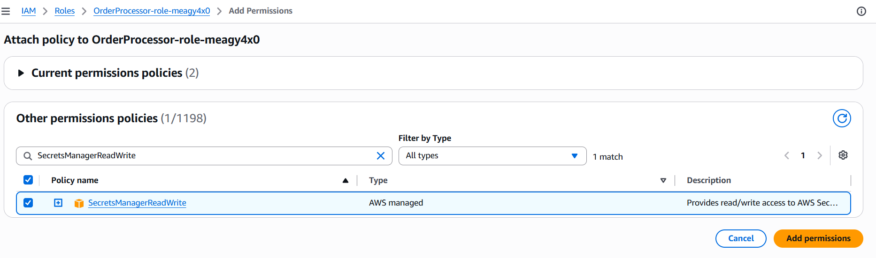
Step 3: Go Back to Lambda
Now open
Lambda
→ OrderProcessor
→ Code
Replace the code with:
import boto3
def lambda_handler(event, context):
client = boto3.client('secretsmanager')
response = client.get_secret_value(
SecretId='Maria-DB-Secret'
)
print(response['SecretString'])
return {
'statusCode': 200,
'body': 'Secret Retrieved Successfully'
}
Replace Maria-DB-Secret with your exact secret name if it's different.

Step 4: Deploy
Click the orange
Deploy
button. 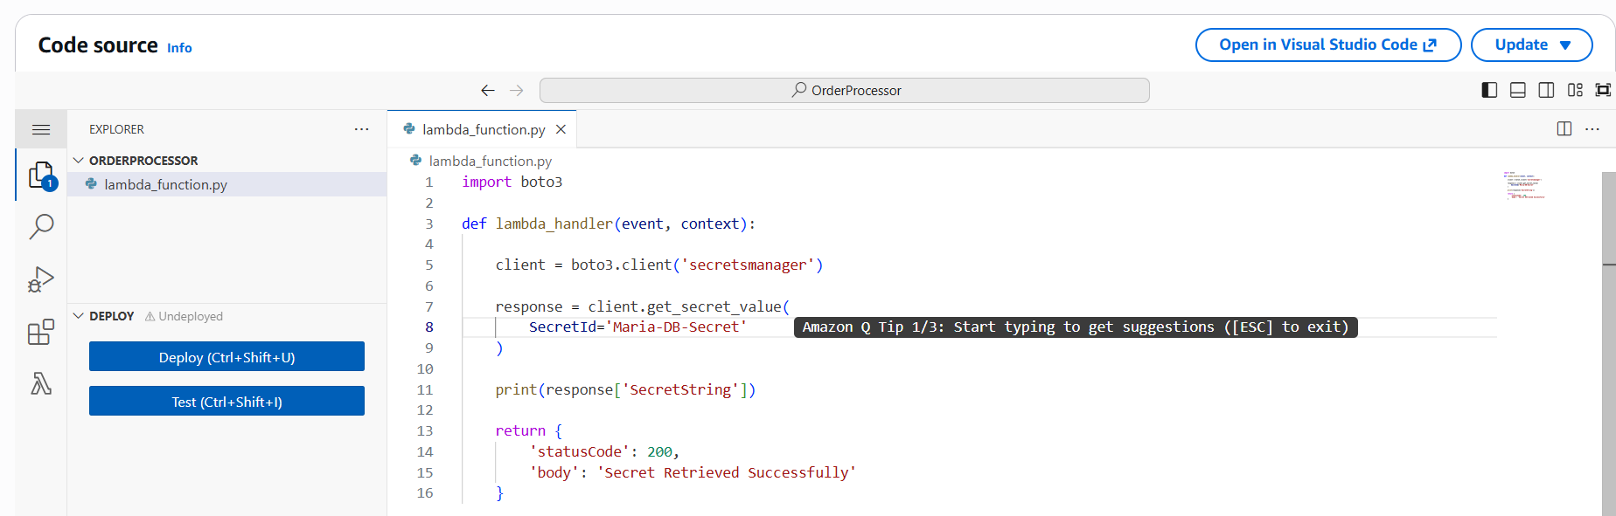

Step 5: Test
Click
Test
↓
Create a new test event.
Name:
TestSecret
Leave the default JSON:
{}
Click
Save
Click
Test

Step 6: Check the Output
If everything is correct, you'll see:
Status: Succeeded

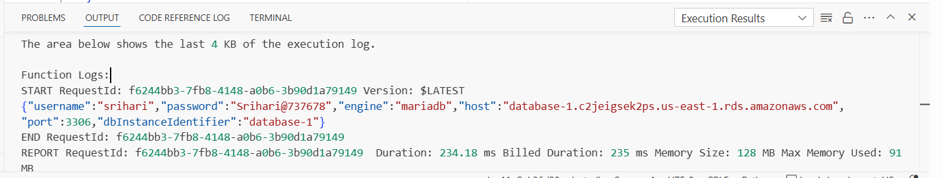

Why Use Secrets Manager?
❌ Hardcoded password:
password = "Password@123"
Problems:
- Anyone with access to the code can see it.
- Changing the password requires updating and redeploying the application.

